Patient Intake Form
Patient Information
Full Name: _______________________________________________________ Birth Date: _______________________
Address: __________________________________________________________ Apt. # ___________________________
City: _________________________________________State: __________________ Zip: _________________________
Age: __________________ Female:_____________ Male:____________ Height:_____________ Weight:____________
Home Phone: _____________________ Work Phone: _____________________ Cell/Other: __________________
I prefer to receive calls at (circle) Home / Work / Cell
I am (Circle one): Under age 18 / Single / Married / Divorced / Widowed / Separated / Partnership
Email: ________________________________________________
Family Doctor: ______________________________________ Telephone: _________________________________
Employer: ____________________________________________ Occupation: ______________________________
Spouse’s Name: _________________________________ Spouse’s Date of Birth: ___________________
Emergency Contact: _________________________ Emergency Contact Phone Number: _________________

IS THIS A WORK-RELATED ACCIDENT OR MOTOR VEHICLE ACCIENT? ______________________________________

Who referred you to us or how did you hear about us? ___________________________________________
Payment Information
Person Responsible for Payment: ___________________________________________________________________
Phone: _________________________________ Date of Birth: _____________________________

Insurance Information
Do you have health insurance? _________ Yes ___________ No

***Please have your insurance card and driver’s license ready so they can be copied for the clinic’s records. ***

Medical History:
Primary care Physician: __________________________________ Phone: _________________________________
Date last seen: ________________________________ May we update them on your condition? ____Yes ____No
Have you seen a chiropractor before? ____No ____ Yes, when and why? __________________________________
_____________________________________________________________________________________________
Name of previous chiropractor: ___________________________________________________________________
Have you seen another doctor for these symptoms? IF yes, indicate name and type of medical provider: ________
_____________________________________________________________________________________________
Do you exercise? _____No _____Yes: Hours per week _____________ What activity(s)? _____________________________
Are you dieting? ___ No ___Yes: Since: ________ Do you smoke? ___No ___ Yes _______packs per day
How many years have you been smoking? ______ Do you drink alcoholic beverages? ___No ____Yes: drinks per day _____
Do you wear? _____ Heal lifts ____Arch supports ____Prescription Orthotics
For women: Are you pregnant or nursing? ___Yes ___No If pregnant, how many weeks? _________
Date of last menstrual period: ___________________________
Are you taking birth control: ____ No ____Yes, since: __________________ Rx: ____________________

Signed _________________________________________________________________ Date ______________________________
Health Questionnaire
Medical History
Describe the reason(s) for your doctor visit today: ____________________________________________________
_____________________________________________________________________________________________
When did your symptoms start? ________________________ How did your symptoms begin? ________________ _____________________________________________________________________________________________
What have you done for this so far? (Ice, Heat, Medications) ____________________________________________
How often do you experience symptoms? (Circle one) Constantly Frequently Occasionally Intermittently
Describe your symptoms? (Circle all that apply) Sharp Dull ache Numbing Burning Tingling Shooting
Are your symptoms? (Circle one) Getting better Staying the same Getting worse
How do your symptoms interfere with your work or normal activities? ____________________________________ _____________________________________________________________________________________________
Have you experienced these symptoms in the past? ___________________________________________________

Description of Condition
Mark any area(s) of discomfort with the following key:
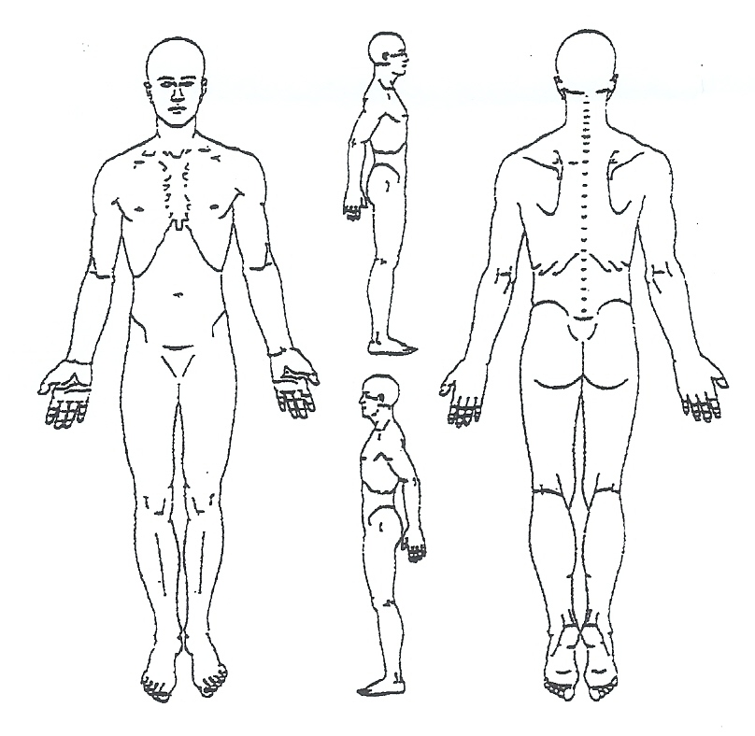
A=Ache N=Numbness B=Burning T=Tingling S=Stiffness O=Other

Pain Severity Scale
No pain 0 1 2 3 4 5 6 7 8 9 10 Unbearable
On a scale of one to ten how intense are your symptoms at their worst? _____________
On a scale of one to ten how intense are your symptoms at their best? ______________
How do your symptoms affect your actual daily living? __________________________________________________________
What are you having difficulty doing since your symptoms began:__________________________________________________
Do your symptoms wake you from sleep? _____________________________________________________________________

Patient Name: __________________________________________________ Date: ______________________________

Past Medical History:
Have you ever had or do you currently have any of the following:
О Heart Attack/Stroke O Arthritis O Headaches O Numbness/Tingling
O Congenital Heart Defect O Neck Pain O Diabetes O Muscle Spasm
O Alcohol/Drug Abuse O Jaw Pain O Dizziness/Vertigo O Difficulty Sleeping
O Fainting/Drop Attacks O Wrist Pain O Emphysema O Digestive Disorders
O Seizures/Epilepsy O Shoulder Pain O Kidney Problem O Unusual Bleeding
O Shingles O Arm Pain O Artificial Joints O Chest Pain
O Depression/Anxiety O Leg Pain O Night Sweats O Nagging Cough
O Difficulty Breathing O Low Back Pain O Osteoporosis O Difficulty Swallowing
O Anemia O Earaches O Ulcer O Changes in Vision
O Hepatitis O Ringing in ears O Gout O High Blood Pressure
O Cancer O Other pertinent medical history _____________________________________
Type:____________
Year diagnosed:_____
O Medications: __________________________________________________________________________________
_______________________________________________________________________________________________
O Surgeries/Hospitalization (include dates): ___________________________________________________________
_______________________________________________________________________________________________

Do you have a family history of the following:
(Please indicate parent, grandparent, child…)
O Heart Attack/Stroke ____________________ O Unusual Bleeding ____________________
O Congenital Heart Defect ____________________ O Diabetes ____________________
O Alcohol/Drug Abuse ____________________ O Dizziness/Vertigo ____________________
O Fainting/Drop Attacks ____________________ O Emphysema ____________________
O Seizures/Epilepsy ____________________ O Kidney Problem ____________________
O Depression/Anxiety ____________________ O Cancer ____________________
O Anemia ____________________ O Ulcer ____________________
O Headaches ____________________ O Osteopenia ____________________
O Arthritis ____________________ O Osteoporosis ____________________
O Other pertinent medical history _________________________________________________________________

Patient Name:________________________________________ Date:_______________________

Doctor Signature: _________________________________________________________________
Date Reviewed:_________________________________

INSURANCE AND PAYMENT CONTRACT
DEDUCTIBLE INFORMATION: It is your responsibility to know and understand your benefits. If your insurance plan has a deductible, Tri County Chiropractic of Douglassville will collect a partial payment at the time of service and the responsible party will be billed for the remaining amount, if any.

- You authorize your insurance company to pay Tri-County Chiropractic of Douglassville, PC all insurance benefits otherwise payable to you for services rendered. You authorize the use of your signature on all insurance forms and submissions.

- At the beginning of your treatment, or if your insurance changes, our office will make every attempt to verify your policy benefits. However, this office DOES NOT guarantee your insurance policy or payments. In addition, this office is not responsible for inaccurate information quoted by your insurance company.

- If your insurance company has not paid the full balance within 60 days of receiving a claim, a statement will be sent to you requesting payment within 20 days. You will be informed in writing when your account is past due. If payment or payment arrangements are not made, collection will be made through a collection agency. Balances older than 90 days are subject to collection action, as well as collection fees and interest at 6%.

- Copayments and/or co-insurance are due at the time of visit unless prior arrangements were made.

- You authorize Tri-County Chiropractic of Douglassville, PC to release all information necessary to secure payments of benefits. You understand that it is YOUR responsibility for all charges whether or not paid by insurance

- If your insurance company requires a referral from your Primary Care Physician, it is your responsibility to obtain a referral for care.

- You understand that if you do not cancel your appointment 24 hours in advance or do not show, you may be charged a $25.00 fee.

- In some instances, your insurance company may require additional information from you before they will process your claim. It is your responsibility to contact your insurance company with any requested information in a timely manner.

- You permit a copy of this authorization to be used in place of the original.

AUTHORIZATION FOR CHIROPRACTIC TREATMENT
I, the undersigned, a patient or parent/guardian of the minor patient in this office hereby authorize Dr. Melissa Kisla, and Dr. Sarah Cole and whomever they may designate as their assistants to administer treatment as is necessary and to perform therapies, manipulations and procedures as are considered therapeutically necessary on the basis of finding during the course of said treatments.

Although spinal manipulation/adjustment is considered to be one of the safest, most effective forms of therapy for musculoskeletal problems. I am aware that there are possible risks and complications associated with these procedures as follows:
- Soreness: I am aware that, like exercise, it is common to experience soreness in the first few treatments. I am aware that if soreness continues the doctor should be notified.
- Dizziness: temporary symptoms such as dizziness or nausea may occur but are very rare. If dizziness occurs the doctor should be notified.
- Fractures/ joint injury: I understand that in isolated cases physical defects, deformities, or pathologies are detected or suspected this office will process with extra caution.
- Stroke: Stroke from chiropractic care is extremely rare. I am aware that strokes are reported to occur once in one million to once in ten million treatments. Once in one million is about the same risk as getting struck with lightening. Once in ten million is about the same as a normal one time dose of acetaminophen causing death.
Treatment Results
I also understand that there are beneficial effects associated with chiropractic treatment including:
Decreased Pain Improved Mobility
Reduced Muscle Spasm Improved Function
Improved Flexibility Increased Range of Motion
Alternate Treatments Available
I understand that there are reasonable alternatives to care including but not limited to rest, home applications of therapies, prescriptions or over the counter medication, exercises and possibly surgery.
Non-Treatment
I understand the potential risks of refusing or neglecting care may include increased pain, scar/adhesion formation, restricted motion, possible nerve damage, increased inflammation, and worsening pathology. The aforementioned may complicate treatment making future recovery more difficult and lengthy.
I hereby certify that I have read and fully understand the above explanation to chiropractic treatment. Any questions I have regarding these procedures have been answered to my satisfaction prior to signing this consent form. I have made my decision voluntarily and freely.

To attest my consent for these procedures, I hereby affix my signature to this authorization for treatment. I also fully understand and agree to the financial policy.

Print Name: _____________________________________________________ Print patient name if minor: _______________________________________

Signed: _________________________________________________________ Date _____/_____/_____

TCC Witness: _____________________________________

Consent for Use or Disclosure of Health Information
Our Privacy Pledge

We are very concerned with protecting your privacy. While the law requires us to give you this disclosure, please understand that we have, and always will, respect the privacy of your health information.

There are several circumstances in which we may have to use or disclose your health care information.

- We may have to disclose you health information to another health care provider or a hospital if it is necessary to refer you to them for the diagnosis, assessment, or treatment of your health condition.
- We may have to disclose your health information and billing records to another party if they are potentially responsible for the payment of your services.
- We may need to use your health information within our practice for quality control or other operational purposes.
We have a more complete notice that provides a detailed description of how your health information may be used or disclosed. You may have the right to review that notice before you sign this consent form (act 164.520). We reserve the right to change our privacy practices as described in the notice. If we make a change to our privacy practices, we will notify you in writing when you come in for treatment or by mail. Please feel free to call us at any time for a copy of our privacy notices

Your Right to Limit Uses or Disclosures

You have the right to request that we do not disclose your health information to specific individuals, companies, or organizations. If you would like to place any restrictions on the use or disclosure of your health information, please let us know in writing. We are not required to agree to your restrictions. However, if we agree with your restrictions, the restriction is binding on us.

Your Right to Revoke Your Authorization

You may revoke your consent to us at anytime; however, your revocation must be in writing. We will not be able to honor your revocation request if we already released your health information before we receive your request to revoke your authorization. If you were required to give your authorization as a condition of obtaining insurance, the insurance company may have a right to your health if they decide to contest any of your claims.

Assignment & Release – By signing below, I authorize Tri County Chiropractic of Douglassville to release medical records required by my insurance company(s). I authorize my insurance company(s) to pay benefits directly to Tri County Chiropractic of Douglassville, and I agree that a reproduced copy of this authorization will be as valid as the original. I understand that I am responsible for any amount not covered by my insurance, or any amount for a patient for which I am the guarantor. I agree that I will be responsible for any collection agency or attorney fees incurred. I understand that by signing below, I am giving written consent for the use and disclosure of protected health information for treatment, payment, and health care operations.

Consent for Treatment
By signing below, I give my consent for examination and the performance any tests or procedures needed. If patient is a minor, by signing I give consent for examination, tests and procedures for the above minor patient.

I have read your consent policy and agree to its terms. I am acknowledging that I have received a copy of this notice.

____________________________________
Printed Name of Minor, if applicable

____________________________________ ____________________________________
Printed Name Authorized Provider Representative

____________________________________ ____________________________________
Signature Date

________________________________________
Date

